Medieval Latin

Prof. Marie-Claire Beaulieu

Tufts University

**Instructions for timelines and map assignments**

**Instructions**

1. Use the fictional itinerary you put together with the Hereford Map
2. Calculate the time it will take you to get from one city to another using <http://orbis.stanford.edu/>
3. Choose a fictional start date for your journey
4. Go to <http://timemapper.okfnlabs.org/>

Please adhere to the following data guidelines and best practices when creating [TimeMapper](http://timemapper.okfnlabs.org/) spreadsheets. A sample spreadsheet which adheres to these guidelines can be found at <https://docs.google.com/spreadsheet/ccc?key=0AsEF52NLjohvdENORUVIZ1NNNTVwVE9QakRHbDBQRmc#gid=0>

1. Build your spreadsheet from a copy of the template spreadsheet provided by the Open Knowledge Foundation at <https://docs.google.com/a/okfn.org/spreadsheet/ccc?key=0AqR8dXc6Ji4JdFRNOTVYYTRqTmh6TUNNd3U2X2pKMGc#gid=0>
2. Format of dates for “Start” and “End” data columns:
   1. BCE Dates should be formatted as -YYY BCE
      1. e.g. -700 BCE
   2. AD Dates should be formatted as YYYY AD
      1. e.g. 0001 AD
3. “Web Page” data column entries for Timeline topics:
   1. *Text from Perseus*: if referencing a text from Perseus as the topic of a timeline entry, you must use the canonical Citation URI for the citation in the “Web Page” column of the row of the timeline spreadsheet. This URI can be found in the Stable Identifiers widget on the text display in Perseus:

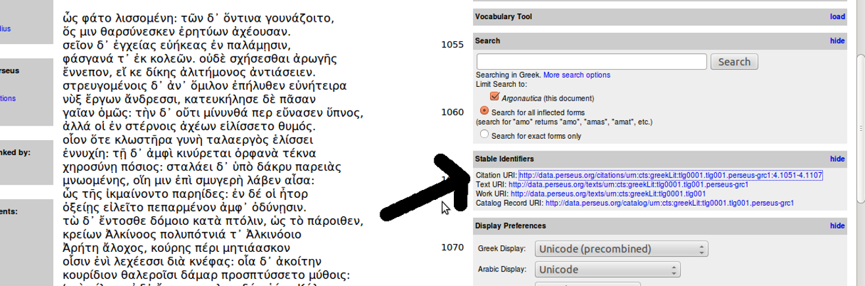

E.g. the URI in the example above: <http://data.perseus.org/citations/urn:cts:greekLit:tlg0001.tlg001.perseus-grc1:4.1051-4.1107> should be used as the contents of the “Web Page” column for a timeline item.

1. *Perseus Artifacts*: If referencing an Artifact from the Perseus Art and Archaeology collection, you must use the Permalink for the artifact in the “Web Page” column of the row of the timeline spreadsheet. This link can be found at the top left of the artifact description page in Perseus:

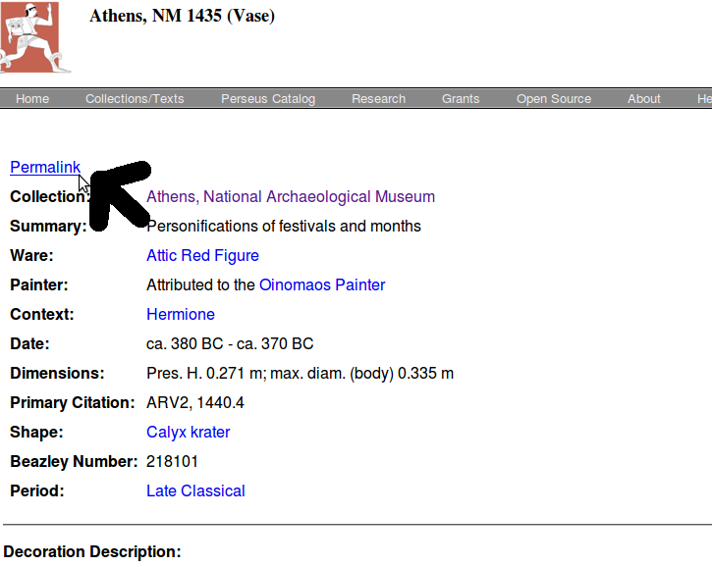

Right click on the link to copy the link location. E.g. in the example above, the link to be used into the spreadsheet is <http://data.perseus.org/artifacts/vase/Athens%2C+NM+1435>

1. *Other Resources:* When using any non-Perseus resource as the topic of a timeline entry, it is best to try to find and use the Stable URIs for the resource, if this information is made available by the resource provider. It may be referenced as “Permalink” as we do in Perseus for Artifacts, or “Canonical URI” or other similar terminology. If it is not available, a link to the web page will be fine.
2. “Place” and Location”: Mapping Data using Pleiades: if you are mapping an ancient place to a text or object, it is best to reference the URI and coordinates from the [Pleiades Gazetteer](http://pleiades.stoa.org/). You can use the search form to search for a place by name. When you have found the place you want to map, follow these steps:
   1. Copy the Canonical URI for the place into the “Place” column in your google spreadsheet. This can be found near the middle of the main page for a Pleiades place:

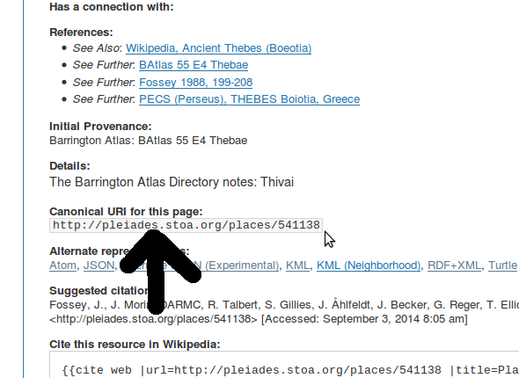

1. Put the coordinates (latitude and longitude) for the place in the “Location” column of the google spreadsheet. It’s best to use the geoJSON format for this. You can find this for Pleiades places by clicking on the DARE or DARMC location links that appear to the right of the map:

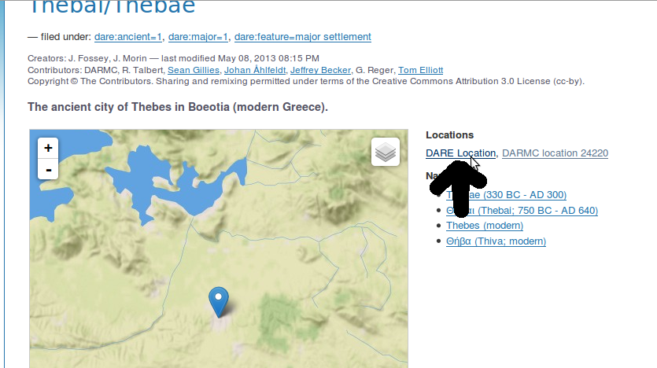

1. When you click on this link, you will see the coordinates represented under a field entitled “Geometry and Coordinates” as in the example below. Copy this information into the “Location” field of your google spreadsheet:

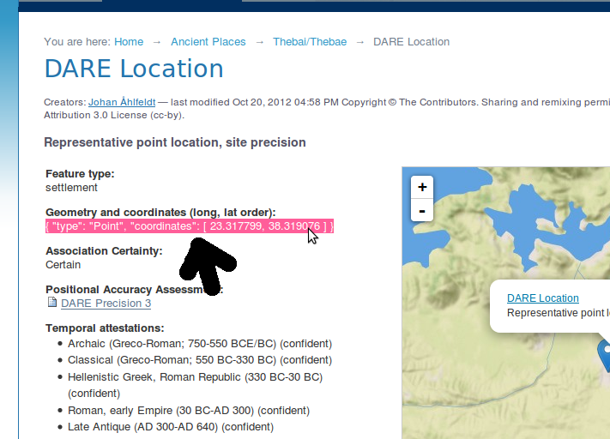

e.g. in this example, the data to be pasted into the “Location” column of the spreadsheet is: **{ "type": "Point", "coordinates": [ 23.317799, 38.319076 ] }** Make sure to copy the {} and [] exactly as appears on the page.

1. If Pleiades does not include your location (for instance if it is located in the Arab world), use the Al-Thurayyā Gazetteer: <http://maximromanov.github.io/projects/althurayya_02/>

You will need to find out the Arabic name of the city you are looking for (use Wikipedia).

1. “Media” and “Media Credit”: If you are including images in your timeline, the link to the image should go in the “Media” column of the google spreadsheet. Be sure also to include the appropriate copyright information in the “Media Credit” column. This information can usually be easily found on the site hosting the image.
2. Follow the instructions to submit to Perseids here: <http://sites.tufts.edu/perseids/instructions/uploading-googlespreadsheet-data-as-annotations/>